Batch: A2 Roll No.: 16010322014
Experiment / assignment / tutorial No. 5
Grade: AA / AB / BB / BC / CC / CD /DD
Signature of the Staff In-charge with date

Title: Configure Extended VLANs, VTP, and DTP

Objectives:
Part 1: Configure VTP
Part 2: Configure DTP
Part 3: Add VLANs and Assign Ports
Part 4: Configure Extended VLAN

OUTCOME:
CO 2. Implement enhanced switching technologies and first hop redundancy protocols

Tools required:
Packet Tracer software

Theory:
It can become challenging to manage VLANs and trunks in a network, as the number of switches increases. VLAN trunking protocol (VTP) allows a network administrator to automate the management of VLANs. Automated trunk negotiation between network devices is managed by the Dynamic Trunking Protocol (DTP). DTP is enabled by default on Catalyst 2960 and Catalyst 3560 switches.
Configure trunk links between the switches. Configure a VTP server and VTP clients in the same VTP domain. Configure an extended VLAN on one of the switches, assign ports to VLANs and verify end-to-end connectivity within the same VLAN.

Task:
Topology
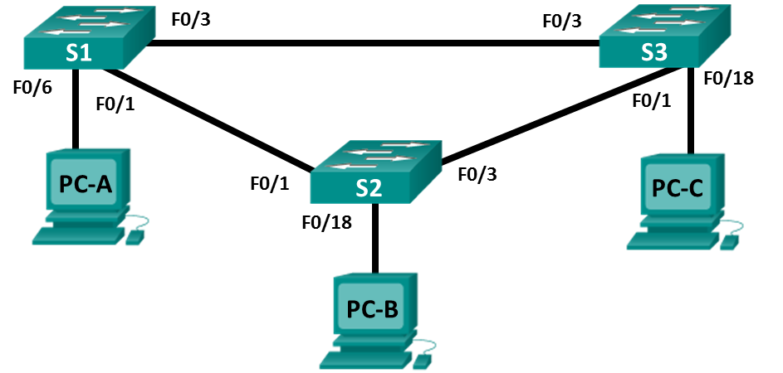

Addressing Table
Table Heading | Interface | IP Address | Subnet Mask
S1 | VLAN 99 | 192.168.99.1 | 255.255.255.0
S2 | VLAN 99 | 192.168.99.2 | 255.255.255.0
S3 | VLAN 99 | 192.168.99.3 | 255.255.255.0
PC-A | NIC | 192.168.10.1 | 255.255.255.0
PC-B | NIC | 192.168.20.1 | 255.255.255.0
PC-C | NIC | 192.168.10.2 | 255.255.255.0

- Configure VTP
All the switches will be configured to use VTP for VLAN updates. S2 will be configured as the server. Switches S1 and S3 will be configure as clients. They will be in the CCNA VTP domain using the password cisco.
      - Configure S2 as a VTP server in the CCNA VTP domain using cisco as the VTP password.
S2(config)# vtp domain CCNA

- Changing VTP domain name from NULL to CCNA

- S2(config)#

- *Mar 1 00:03:44.193: %SW_VLAN-6-VTP_DOMAIN_NAME_CHG: VTP domain name changed to CCNA.
S2(config)# vtp mode server

- Device mode already VTP Server for VLANS.
S2(config)# vtp password cisco
Setting device VTP password to cisco

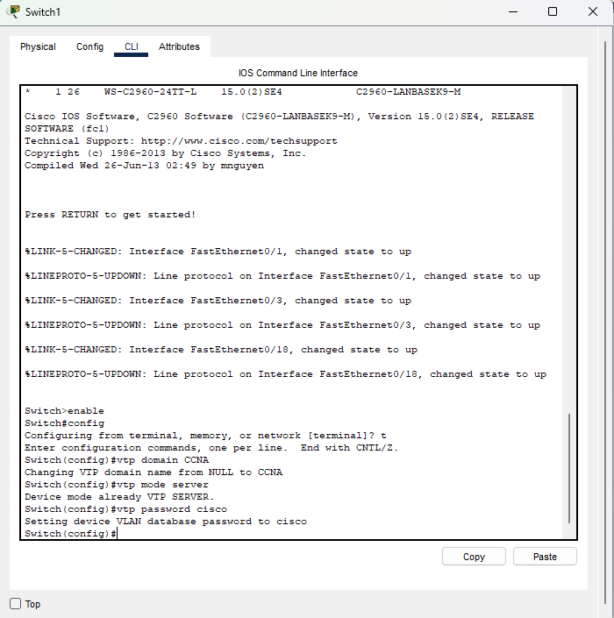
      - Configure S1 and S3 as VTP clients in the CCNA VTP domain using cisco as the VTP password. VTP configurations are displayed below.
S1(config)# vtp domain CCNA
Changing VTP domain name from NULL to CCNA
S1(config)#
*Mar 1 00:03:44.193: %SW_VLAN-6-VTP_DOMAIN_NAME_CHG: VTP domain name changed to CCNA.
S1(config)# vtp mode client

Device mode VTP client for VLANS.
S1(config)# vtp password cisco

Setting device VTP password to cisco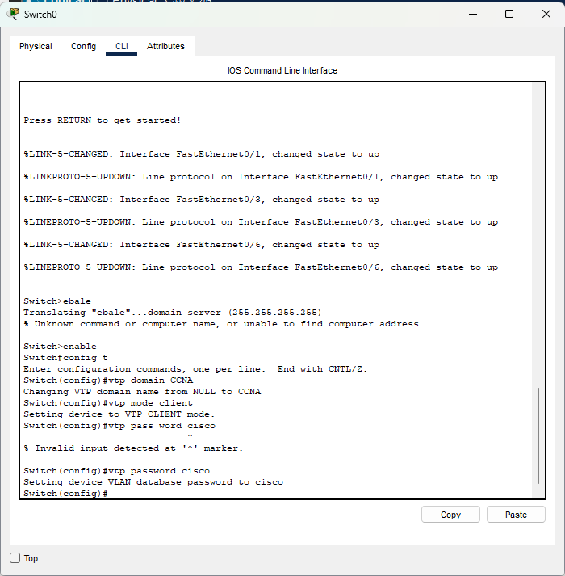

      - Verify VTP configurations by entering the show vtp status command on all switches. The VTP status for S3 is displayed below.
S3# show vtp status
VTP Version capable : 1 to 3
VTP version running : 1
VTP Domain Name : CCNA
VTP Pruning Mode : Disabled
VTP Traps Generation : Disabled
Device ID : 0cd9.96d2.3580
Configuration last modified by 0.0.0.0 at 0-0-00 00:00:00

Feature VLAN:
--------------
VTP Operating Mode : Client
Maximum VLANs supported locally : 255
Number of existing VLANs : 5
Configuration Revision : 0
MD5 digest : 0x8B 0x58 0x3D 0x9D 0x64 0xBE 0xD5 0xF6
0x62 0xCB 0x4B 0x50 0xE5 0x9C 0x6F 0xF6

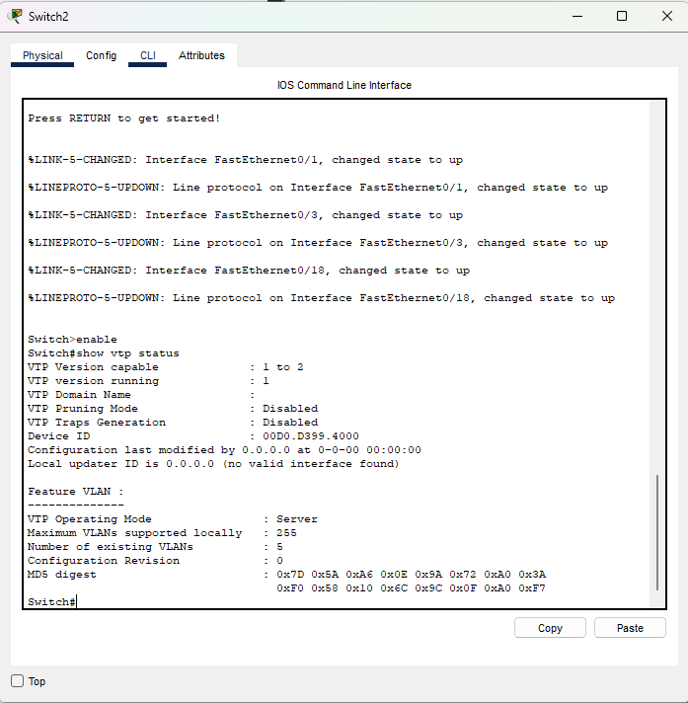
- Configure DTP
    - Configure dynamic trunk links between S1 and S2.
      - Enter the show interfaces f0/1 switchport command on S1 and S2.
What is the administrative and operational mode of switchport f0/1?
The administrative mode is dynamic auto and the operational mode is static access on f0/1 interface for both switches.

__________________________________________________________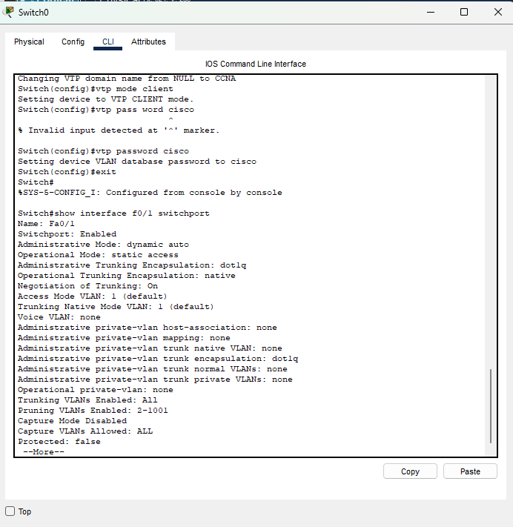__________________________
      - In interface configuration mode, configure a dynamic trunk link between S1 and S2. Because the default mode is dynamic auto, only one side of the link needs to be configured as dynamic desirable.
S1(config)# interface f0/1
S1(config-if)# switchport mode dynamic desirable
S1(config-if)#

- *Mar 1 00:30:45.082: %LINEPROTO-5-UPDOWN: Line protocol on Interface FastEthernet0/1, changed state to down

- *Mar 1 00:30:48.102: %LINEPROTO-5-UPDOWN: Line protocol on Interface FastEthernet0/1, changed state to up

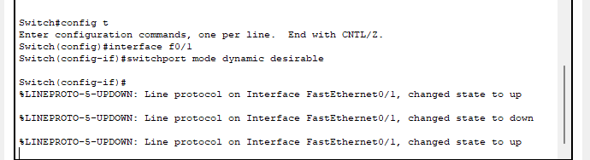

      - Verify trunking link between S1 and S2 using the show interfaces trunk command.
S1# show interfaces trunk

Port Mode Encapsulation Status Native vlan
Fa0/1 desirable 802.1q trunking 1

Port Vlans allowed on trunk
Fa0/1 1-4094

Port Vlans allowed and active in management domain
Fa0/1 1

Port Vlans in spanning tree forwarding state and not pruned
Fa0/1 none
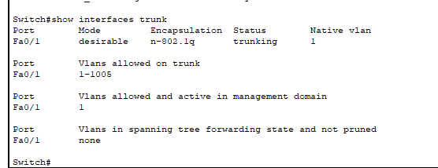

S2# show interfaces trunk

Port Mode Encapsulation Status Native vlan
Fa0/1 auto 802.1q trunking 1

Port Vlans allowed on trunk
Fa0/1 1-4094

Port Vlans allowed and active in management domain
Fa0/1 1

Port Vlans in spanning tree forwarding state and not pruned
Fa0/1 1
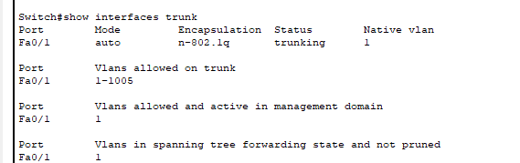
    - Configure static trunk link between S1 and S3.
      - Between S1 and S3, configure a static trunk link using the switchport mode trunk command in the interface configuration mode for port F0/3.
S1(config)# interface f0/3
S1(config-if)# switchport mode trunk
      - Verify the trunks using show interfaces trunk command on S1.
S1# show interface trunk

Port Mode Encapsulation Status Native vlan
Fa0/1 desirable 802.1q trunking 1
Fa0/3 on 802.1q trunking 1

Port Vlans allowed on trunk
Fa0/1 1-4094
Fa0/3 1-4094

Port Vlans allowed and active in management domain
Fa0/1 1
Fa0/3 1

Port Vlans in spanning tree forwarding state and not pruned
Fa0/1 none
Fa0/3 none
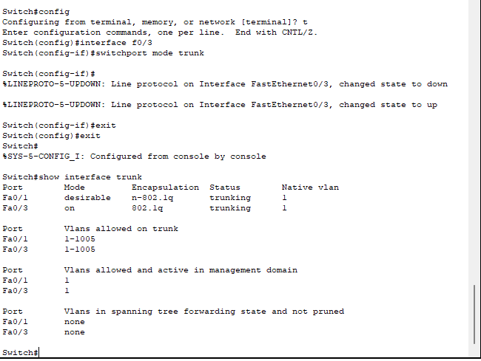
      - Configure a permanent trunk between S2 and S3.
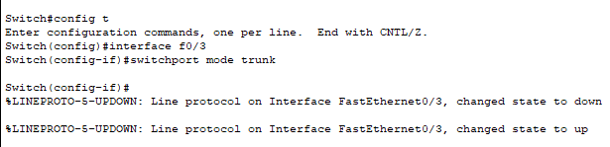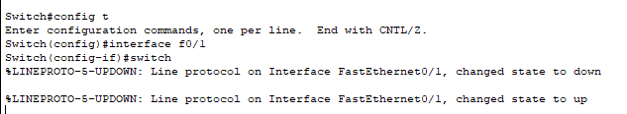
      - Record the commands you used to create the static trunk.
____________________________________________________________________________________
____________________________________________________________________________________
- Add VLANs and Assign Ports

    - Add VLANs on the switches.
      - On S1, add VLAN 10.
S1(config)# vlan 10
Were you able to create VLAN 10 on S1? Explain.
You cannot add a new VLAN when the switch is in VTP client mode.

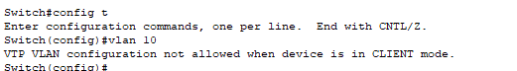
      - On S2, add the following VLANs.

VLAN | Name
10 | Red
20 | Blue
30 | Yellow
99 | Management

S2(config)# vlan 10
S2(config-vlan)# name Red
S2(config-vlan)# vlan 20
S2(config-vlan)# name Blue
S2(config-vlan)# vlan 30
S2(config-vlan)# name Yellow
S2(config-vlan)# vlan 99
S2(config-vlan)# name Management
S2(config-vlan)# end

S2# show vlan brief

VLAN Name Status Ports
---- -------------------------------- --------- -------------------------------
1 default active Fa0/2, Fa0/4, Fa0/5, Fa0/6
Fa0/7, Fa0/8, Fa0/9, Fa0/10
Fa0/11, Fa0/12, Fa0/13, Fa0/14
Fa0/15, Fa0/16, Fa0/17, Fa0/18
Fa0/19, Fa0/20, Fa0/21, Fa0/22
Fa0/23, Fa0/24, Gi0/1, Gi0/2
10 Red active
20 Blue active
30 Yellow active
99 Management active
<output omitted>
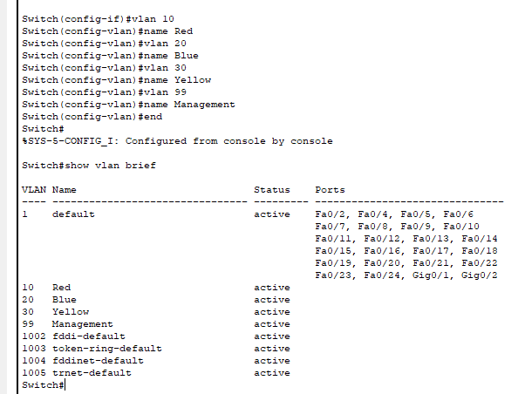
    - Verify VTP updates on S1 and S3.
Because S2 is configured as a VTP server, and S1 and S3 are configured as VTP clients, S1 and S3 should learn and implement the VLAN information from S2.
What show commands did you use to verify the VTP updates on S1 and S3?
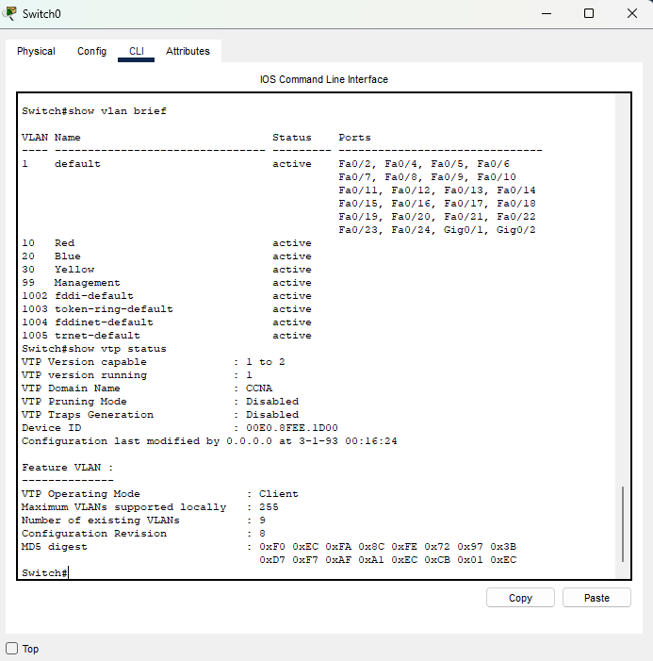

    - Assign ports to VLANs.
In this step, you will associate ports to VLANs and configure IP addresses according to the table below.

Port Assignment | VLAN | Attached PC IP Address and Prefix
S1 F0/6 | VLAN 10 | PC-A: 192.168.10.1 / 24
S2 F0/18 | VLAN 20 | PC-B: 192.168.20.1 /24
S3 F0/18 | VLAN 10 | PC-C: 192.168.10.2 /24

      - On S1, configure F0/6 to access mode and assign F0/6 to VLAN 10.
S1(config)# interface f0/6
S1(config-if)# switchport mode access
S1(config-if)# switchport access vlan 10

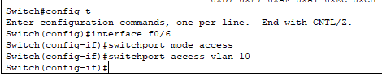
      - Repeat the procedure for switchport F0/18 on S2 and S3. Assign the VLAN according to the table above.
      - Assign the IP addresses to the PCs according to the table above.
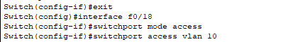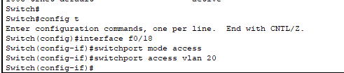
    - Configure IP addresses on the switches.
      - On S1, assign an IP address to the SVI for VLAN 99 according to the Addressing Table and activate the interface.
S1(config)# interface vlan 99
S1(config-if)# ip address 192.168.99.1 255.255.255.0
S1(config-fi)# no shutdown

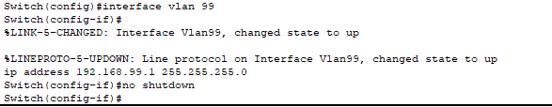
      - Repeat step a. for S2 and S3.
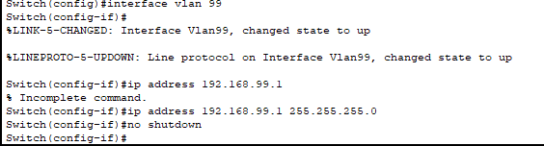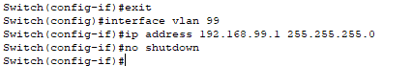
    - Verify end-to-end connectivity
      - Ping PC-A from PC-B. Was it successful? Explain.
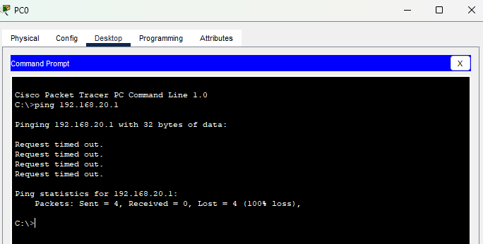
The ping was not successful because they are not in the same VLAN.
_________________________________________________________________________________
      - Ping PC-A from PC-C. Was it successful? Explain.
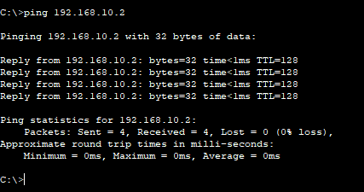
The ping was successful because they are in the same VLAN.
_________________________________________________________________________________
      - Ping PC-A from S1. Was it successful? Explain.
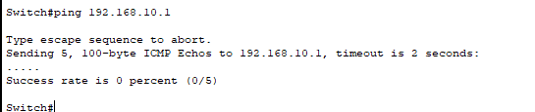
The ping was not successful because they are not in the same VLAN.

_________________________________________________________________________________
d. Ping S1 from S2. Was it successful? Explain.

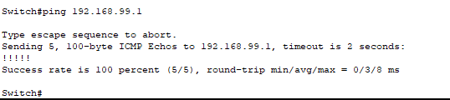
The ping was successful because they are in the same VLAN.

_________________________________________________________________________________

- Configure Extended VLAN
An extended VLAN is a VLAN between 1025 and 4096. Because the extended VLANs cannot be managed with VTP, VTP must be configured in transparent mode. In this part, you will change the VTP mode on S1 to transparent and create an extended VLAN on S1.

    - Configure VTP mode to transparent on S1.
      - On switch S1, set VTP mode to transparent.
S1(config)# vtp mode transparent
Setting device to VTP Transparent mode for VLANS.
S1(config)# exit
      - Verify the VTP mode on S1.

S1# show vtp status
VTP Version capable : 1 to 3
VTP version running : 1
VTP Domain Name : CCNA
VTP Pruning Mode : Disabled
VTP Traps Generation : Disabled
Device ID : 0cd9.96e2.3d00
Configuration last modified by 0.0.0.0 at 3-1-93 02:36:11

Feature VLAN:
--------------
VTP Operating Mode : Transparent
Maximum VLANs supported locally : 255
Number of existing VLANs : 9
Configuration Revision : 0
MD5 digest : 0xB2 0x9A 0x11 0x5B 0xBF 0x2E 0xBF 0xAA
0x31 0x18 0xFF 0x2C 0x5E 0x54 0x0A 0xB7
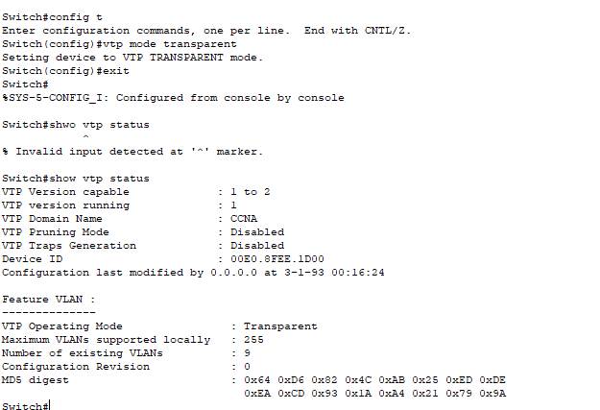
    - Configure an extended VLAN on S1.
      - Display the current VLAN configurations on S1.
      - Create an extended VLAN 2000.

S1# conf t
Enter configuration commands, one per line. End with CNTL/Z.
S1(config)# vlan 2000
S1(config-vlan)# end
      - Verify the VLAN creation.

S1# show vlan brief

VLAN Name Status Ports
---- -------------------------------- --------- -------------------------------
1 default active Fa0/2, Fa0/4, Fa0/5, Fa0/7
Fa0/8, Fa0/9, Fa0/10, Fa0/11
Fa0/12, Fa0/13, Fa0/14, Fa0/15
Fa0/16, Fa0/17, Fa0/18, Fa0/19
Fa0/20, Fa0/21, Fa0/22, Fa0/23
Fa0/24, Gi0/1, Gi0/2
10 Red active Fa0/6
20 Blue active
30 Yellow active
99 Management active
1002 fddi-default act/unsup
1003 token-ring-default act/unsup
1004 fddinet-default act/unsup
1005 trnet-default act/unsup
2000 VLAN2000 active
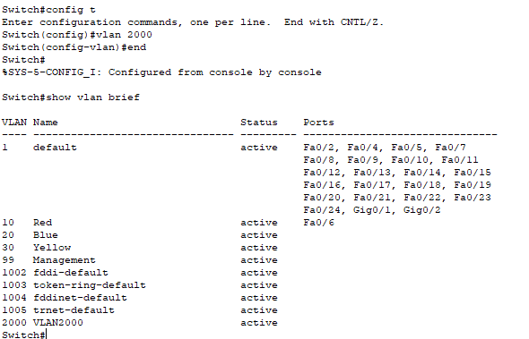
Reflection
What are the advantages and disadvantages of using VTP?
VTP can eliminate the need to manually manage large numbers of VLANs in a network. However, if a switch that is a VTP server with a higher configuration revision number is introduced in the same VTP domain, the information from that switch may adversely change the VLAN configurations of the other switches.
Router Interface Summary Table
Router Interface Summary
Router Model | Ethernet Interface #1 | Ethernet Interface #2 | Serial Interface #1 | Serial Interface #2
1800 | Fast Ethernet 0/0  (F0/0) | Fast Ethernet 0/1  (F0/1) | Serial 0/0/0 (S0/0/0) | Serial 0/0/1 (S0/0/1)
1900 | Gigabit Ethernet 0/0  (G0/0) | Gigabit Ethernet 0/1  (G0/1) | Serial 0/0/0 (S0/0/0) | Serial 0/0/1 (S0/0/1)
2801 | Fast Ethernet 0/0  (F0/0) | Fast Ethernet 0/1  (F0/1) | Serial 0/1/0 (S0/1/0) | Serial 0/1/1 (S0/1/1)
2811 | Fast Ethernet 0/0  (F0/0) | Fast Ethernet 0/1  (F0/1) | Serial 0/0/0 (S0/0/0) | Serial 0/0/1 (S0/0/1)
2900 | Gigabit Ethernet 0/0  (G0/0) | Gigabit Ethernet 0/1  (G0/1) | Serial 0/0/0 (S0/0/0) | Serial 0/0/1 (S0/0/1)

Note: To find out how the router is configured, look at the interfaces to identify the type of router and how many interfaces the router has. There is no way to effectively list all the combinations of configurations for each router class. This table includes identifiers for the possible combinations of Ethernet and Serial interfaces in the device. The table does not include any other type of interface, even though a specific router may contain one. An example of this might be an ISDN BRI interface. The string in parenthesis is the legal abbreviation that can be used in Cisco IOS commands to represent the interface.

Signature of faculty in-charge

